***NAME – KHUSHI PANWAR, khushipanwar26@gmail.com***

***ROLL NO – 33***

***C++ PRACTICAL ASSIGNMENT – 25 NOV 2021***

**WRITE A C++ PROGRAM TO :**

**#1 Display an output**

**#2 Show basic arithmetic functions**

**#3 Take input from the user and display it**

#include<iostream>

using namespace std;

int main()

{

**//Display output using cout**

cout<<"Welcome to C++ Practicals "<<endl;

cout<<"Practice basic arithmetic operations & functions ";

cout<<"in C++ "<<endl;

**//FOR x=5 and y=7, FOLLOWING FUNCTION USED THE BASIC ARITHMETIC OPERATIONS - Addition, Subtraction , Multiplication and Division**

float x,y,sum,diff,prod,div;

x=5;

y=7;

sum=x+y;

diff=y-x;

prod=x*y;

div=y/x;

cout<<"\nThe value of x is "<<x<<"\nThe Value of y is "<<y<< endl;

cout<<"The sum of x and y is "<<sum<<endl;

cout<<"The difference btw x and y is "<<diff<<endl;

cout<<"The product of x and y is "<<prod<<endl;

cout<<"Y divided by x is "<<div<<endl;

**//TAKE INPUT USING cin OBJECT AND SHOW THE OUTPUT**

char ch;

cout<<"\nEnter any character here ";

cin>>ch;

cout<<"The entered character is "<<ch<<endl;

return 0;

}

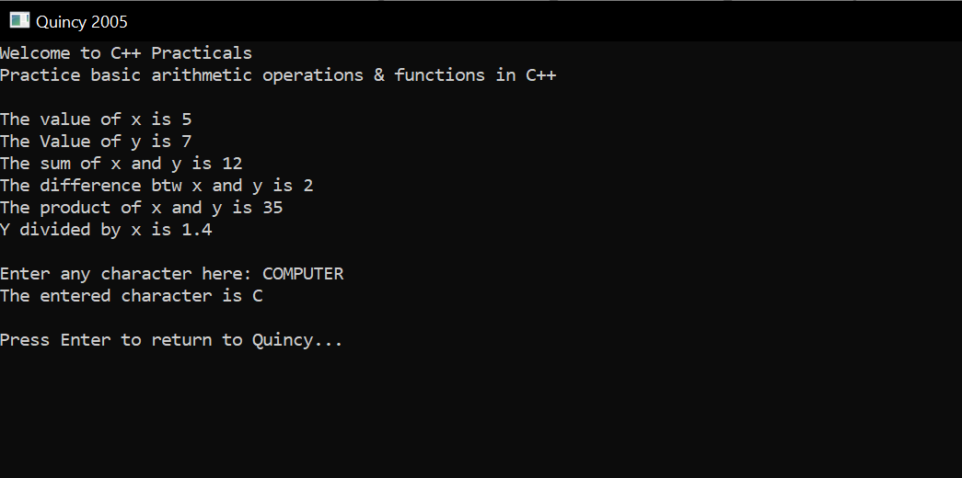

**#4- PERFORMING ARITHMETIC OPERATIONS ON THE NUMBERS INPUT BY THE USER**

#include<iostream>

using namespace std;

float sum(float x,float y){

return x*y;

}

float diff(float x,float y){

return x-y;

}

float prod(float x,float y){

return x*y;

}

float divd(float x,float y){

return x/y;

}

int main()

{

float num1,num2,add,sub,mul,div;

cout<<"Enter first number : "<<endl;

cin>>num1;

cout<<"Enter second number: "<<endl;

cin>>num2;

cout<<"\nThe first number is "<<num1<<endl;

cout<<"The second number is "<<num2<<endl;

add=sum(num1,num2);

sub=diff(num1,num2);

mul=prod(num1,num2);

div=divd(num1,num2);

cout<<"\nThe ADDITION result is "<<add<<endl;

cout<<"The SUBTRACTION result is "<<sub<<endl;

cout<<"The MULTIPLICATION result is "<<mul<<endl;

cout<<"The DIVISION result is "<<div<<endl;

}

